**Supervised Learning: Neural Networks cheat shit:**

Omri Harel

This word contains my cheat shit for neural nets – a summary of major concepts, functions, equations I learned.

Deep Learning

Cost Function (J)

$$J= -\frac{1}{m}\sum_{i=0}^{m}{(y^{\left(i\right)}\log\left(a^{\left[2\right]\left(i\right)}\right)+\left(1-y^{\left(i\right)}\right)\log\left(1- a^{\left[2\right]\left(i\right)}\right))}$$

Gradient Decent

$$dW^{[L]}= \frac{1}{m}dZ^{[L]}A^{{[L-1]}^{T}}$$

$$db^{[L]}= \frac{1}{m}np.sum(dZ^{\left[L\right]}, axis=1, keepdims=True)$$

$$dZ^{[L-1]}= W^{{[L]}^{T}}dZ^{\left[L\right]}*g^{'\left[L-1\right]}(Z^{\left[L-1\right]})$$

Equations for one example (i)

$$z^{[l](i)}=W^{[l]}a^{[l-1](i)}+ b^{[l]}$$

$$a^{[l](i)}=g^{[1]}(z^{\left[1\right]\left(i\right)})$$

Matrix’s Dimensions

General

$$W^{[l]} :(n^{\left[l\right]}, n^{\left[l-1\right]})$$

$$b^{[l]} :(n^{\left[l\right]},1)$$

$$dW^{[l]} : (n^{\left[l\right]}, n^{\left[l-1\right]})$$

$${db}^{[l]} :(n^{\left[l\right]},1)$$

For one example (i)

$$z^{[l]} :(n^{\left[l\right]},1)$$

$$a^{[l]} :(n^{\left[l\right]},1)$$

$${dz}^{[l]} :(n^{\left[l\right]},1)$$

$${da}^{[l]} :(n^{\left[l\right]},1)$$

For an entire set (size m)

$$Z^{[l]} :(n^{\left[l\right]},m)$$

$$A^{[l]} :(n^{\left[l\right]},m)$$

$${dZ}^{[l]} :(n^{\left[l\right]},m)$$

$${dA}^{[l]} :(n^{\left[l\right]},m)$$

$$l=0 :A^{[0]}=X :(n^{\left[0\right]}, m)$$

Input regularization

$$μ= \frac{1}{m}\sum_{i=1}^{m}{X^{(i)}}$$

$σ^{2}= \frac{1}{m}\sum_{i=1}^{m}{{{(X}^{(i)}- μ)}^{2}}$ (Element wise square)

$$X=\frac{X}{σ}$$

L2 Regularization

$$J= \frac{1}{m}\sum_{i=1}^{n}{l(\hat{y^{\left(i\right)}}, y^{\left(i\right)})} + \sum_{i=1}^{n^{l}}{\sum_{j=1}^{n^{[l-1]}}{{(W_{i,j}^{[l]})}^{2}}}$$

$$dW^{[l]}=\left(from backprop\right)+ \frac{λ}{m}W^{[l]}$$

Batch regularization

$$μ=\frac{1}{m}\sum_{i}{z^{(i)}}$$

$$σ^{2}=\frac{1}{m}\sum_{i}{{(z^{\left(i\right)}- μ)}^{2}}$$

$${z^{(i)}}_{norm}= \frac{z^{(i)}- μ}{\sqrt{σ^{2}+ ε}}$$

$${\tilde{z}}^{[l](i)}= γ{z^{(i)}}_{norm}+ β$$

Exponentially weighted average

$v_{t}= βv_{t-1}+(1- β)θ_{t}$

$$*Common β value is 0.9$$

Gradient decent with momentum

$$v_{dw}= β_{1}v_{dw}+(1- β_{1})dW$$

$$v_{db}= β_{1}v_{db}+(1- β_{1})db$$

$$W= W- αv_{dw}$$

$$b= b- αv_{dw}$$

RMSprop

$$s_{dw}= β_{2}s_{dw}+(1- β_{2})dW^{2}$$

$$s_{db}= β_{2}s_{db}+(1- β_{2})db^{2}$$

$$W= W- α\frac{dW}{\sqrt{s_{dw}+ ε}}$$

$$b= b- α\frac{db}{\sqrt{s_{db}+ ε}}$$

Bias correction

$${v_{t}}^{corrected}= \frac{v_{t}}{1- {β_{1}}^{t}}$$

$${s_{t}}^{corrected}= \frac{s_{t}}{1- {β_{2}}^{t}}$$

Adam (Adaptive moment estimation) optimization algorithm

$$v_{dw}= β_{1}v_{dw}+(1- β_{1})dW$$

$$v_{db}= β_{1}v_{db}+(1- β_{1})db$$

$$s_{dw}= β_{2}s_{dw}+(1- β_{2})dW^{2}$$

$$s_{db}= β_{2}s_{db}+(1- β_{2})db^{2}$$

$${v_{dw}}^{corrected}= \frac{v_{dw}}{1- {β_{1}}^{t}}$$

$${v_{db}}^{corrected}= \frac{v_{db}}{1- {β_{1}}^{t}}$$

$${s_{dw}}^{corrected}= \frac{s_{dw}}{1- {β_{2}}^{t}}$$

$${s_{db}}^{corrected}= \frac{s_{db}}{1- {β_{2}}^{t}}$$

$$W= W- α\frac{{v_{dw}}^{corrected}}{\sqrt{{s_{dw}}^{corrected}+ ε}}$$

$$b= b- α\frac{{v_{db}}^{corrected}}{\sqrt{{s_{db}}^{corrected}+ ε}}$$

**Hyperparameters choice**

α: needs to be tuned

$$β_{1}: 0.9 (common)$$

$$β_{2}: 0.999 (common)$$

$$ε: {10}^{-8} (common)$$

Learning rate decay

$$α= \frac{1}{1+decayRate*epochNumber}α_{0}$$

$α={0.95}^{epochNumber}* α_{0}$ (0.95 – example for a number under 1.0)

$$α= \frac{constant}{\sqrt{epochNumber}}α_{0}$$

$$α= \frac{constant}{\sqrt{mini-batch number}}α_{0}$$

Softmax activation function

$$z^{[l]}= w^{[l]}a^{[l-1]}+b^{[l]}$$

$$a^{[l]}= \frac{e^{(z^{\left[l\right]})}}{\sum_{i=1}^{c}{e^{(z^{\left[l\right]})}}}$$

Softmax loss function

$$l\left(\hat{y}, y\right)= -\sum_{j=i}^{c}{y_{j}log⁡({\hat{y}}_{j})}$$

$$J= \frac{1}{m}\sum_{i=1}^{m}{l({\hat{y}}^{\left(i\right)}, y^{(i)})}$$

Softmax gradient decent

$$dz^{\left[l\right]}= \hat{y}-y$$

Harmonic mean

$$Harmonic mean= \frac{2}{\frac{1}{P}+ \frac{1}{R}}$$

$$P-Precision$$

$$R-Recall$$

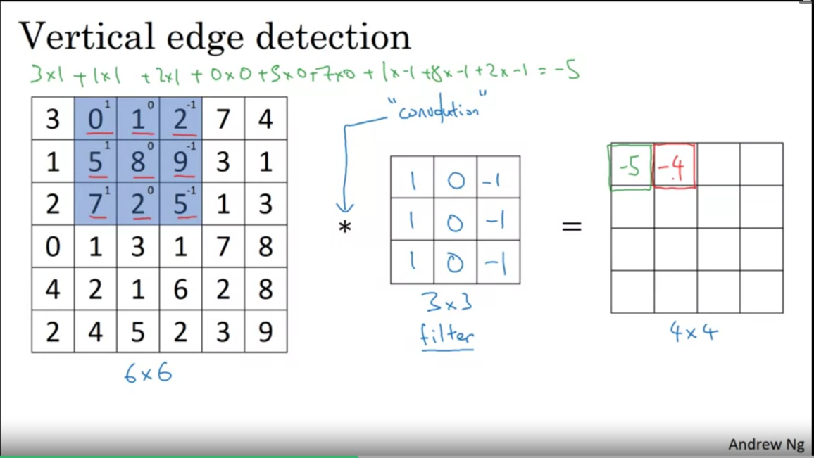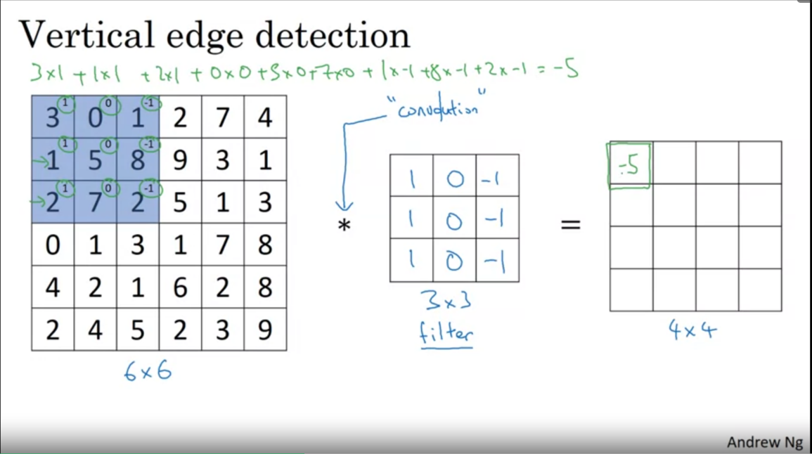Convolution

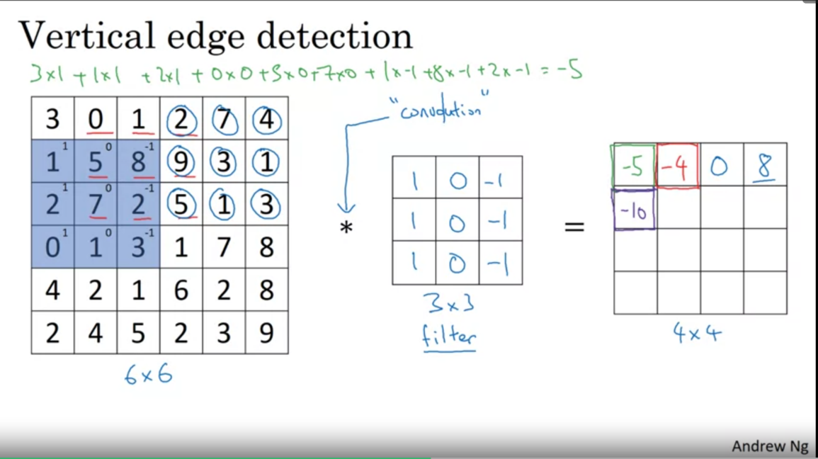

Edge detect filters

|  |  |  |
| --- | --- | --- |
| 1 | 0 | -1 |
| 2 | 0 | -2 |
| 1 | 0 | -1 |

|  |  |  |
| --- | --- | --- |
| 1 | 0 | -1 |
| 1 | 0 | -1 |
| 1 | 0 | -1 |

|  |  |  |
| --- | --- | --- |
| 3 | 0 | -3 |
| 10 | 0 | -10 |
| 3 | 0 | -3 |

General filter

|  |  |  |
| --- | --- | --- |
| $$w_{1}$$ | $$w_{2}$$ | $$w_{3}$$ |
| $$w_{4}$$ | $$w_{5}$$ | $$w_{6}$$ |
| $$w_{7}$$ | $$w_{8}$$ | $$w_{9}$$ |

Padding

p – the amount of ‘borders’ around the image.

Size of output image (n*n) after edge detection with (f*f) filter = (n + 2p – f + 1) * (n + 2p – f + 1)

* f, the size of the filter matrix is usually odd.

**Valid convolution –** no padding (p = 0)

**Same convolution** – pad so the output size is same as the input size (2p – f + 1 = 0)

Strided convolution

Stride – the jump between each filter calculation.

Notation – s

Output size of image with n*n input image size, f*f filter size, p paddings and s strides = ($\frac{n+2p-f}{s}+1$) * ( $\frac{n+2p-f}{s}$ + 1)

**If output size is not integer, we round down the number**

Convolutions on RGB image (3D)

* 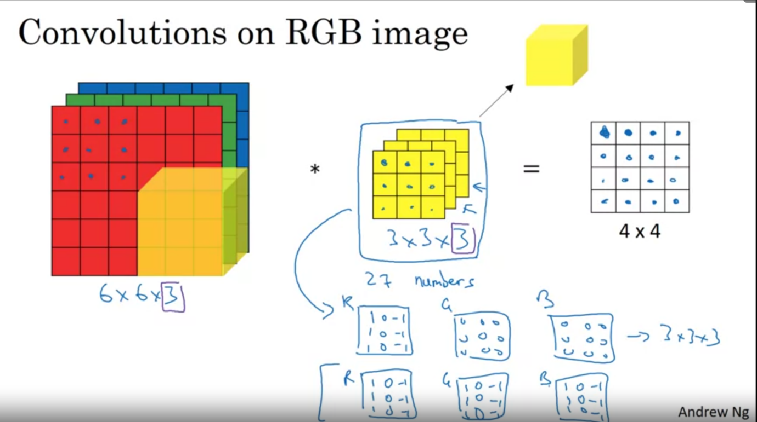sum the value of the layers into one value

Convolutional layer in a NN

$${n_{H}}^{[l]}=floor(\frac{{n_{H}}^{[l-1]}+2p^{[l]}-f^{[l]}}{s^{[l]}})$$

$${n_{W}}^{[l]}=floor(\frac{{n_{W}}^{[l-1]}+2p^{[l]}-f^{[l]}}{s^{[l]}})$$

$${n_{C}}^{[l]}=number of filters in this layer$$

$$filter size= f^{[l]}* f^{\left[l\right]}* {n_{C}}^{[l-1]}$$

$$s^{[l]}=stride$$

$$p^{[l]}=padding$$

$$activations size (a^{\left[l\right]})= {n_{H}}^{[l]}* {n_{W}}^{\left[l\right]}* {n_{C}}^{[l]}$$

$$activations size \left(A^{[l[}\right)= {{m* n}_{H}}^{[l]}* {n_{W}}^{\left[l\right]}* {n_{C}}^{[l]}$$

$$weights size= f^{[l]}* f^{\left[l\right]}* {n_{C}}^{\left[l-1\right]}* {n_{C}}^{\left[l\right]} (filters in layer l)$$

$$bias size= {n_{C}}^{[l]}=(1, 1, 1, {n_{C}}^{\left[l\right]})$$

Max pooling

Output size of max pooling is same as regular filters (using the formula)

* **but the number of channels remains the same!** (example, the input has 10 channels, then the output will have 10 channels).
* *note - there are* ***only hyperparameters (there are no parameters to learn)*** *in Pooling (f: filter size (common value f = 2), s: stride (common value s = 2)) (Padding is rarely used in pooling)*

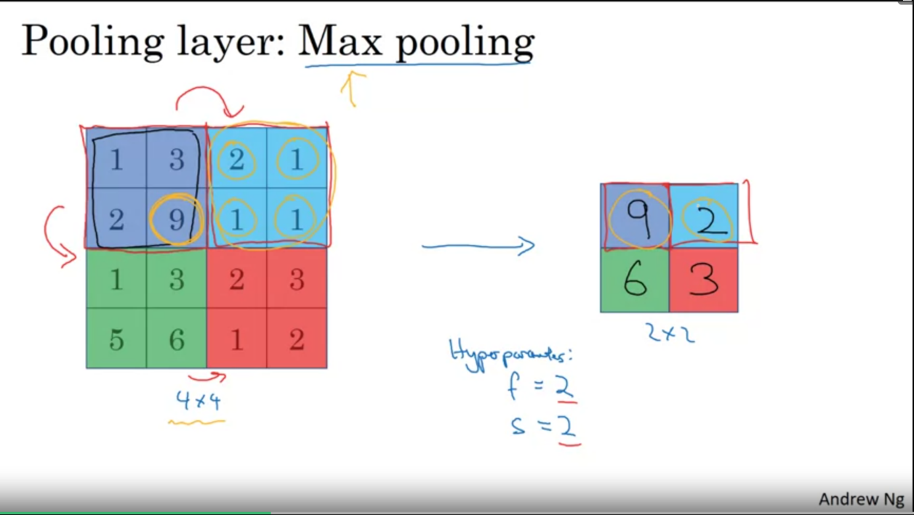

Average pooling

* Output size is same as **Max pooling**

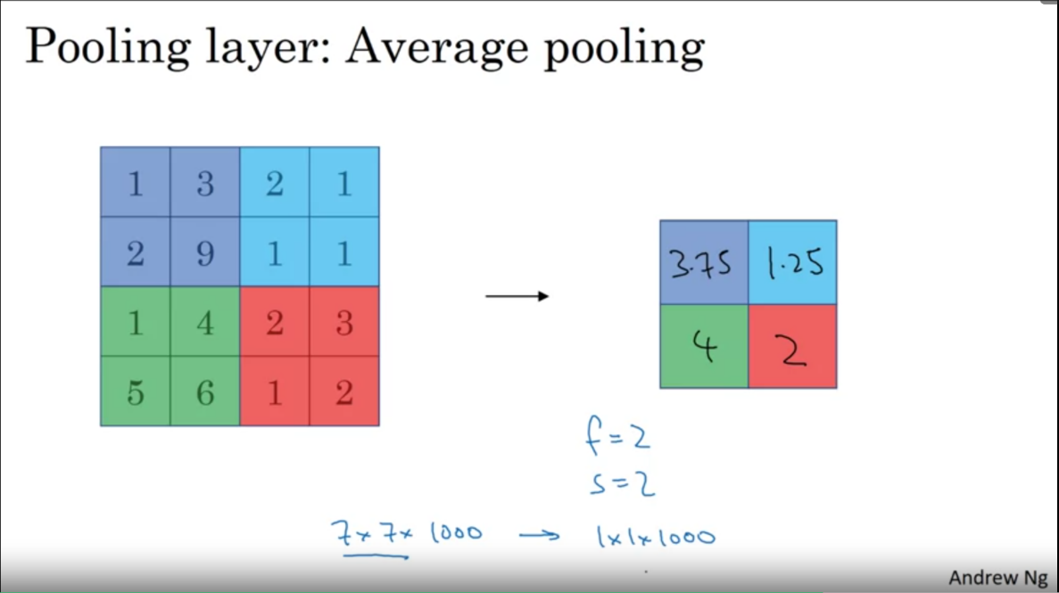

Examples of convNet architectures:

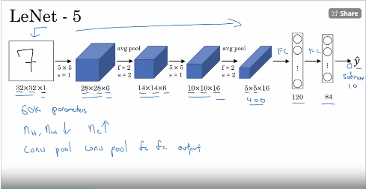- LeNet5:

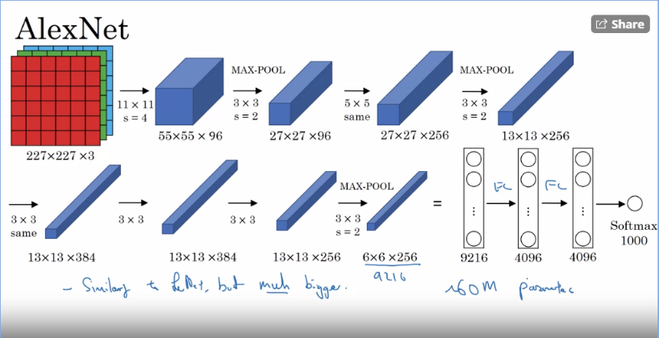- AlexNet:

- VGG-16:

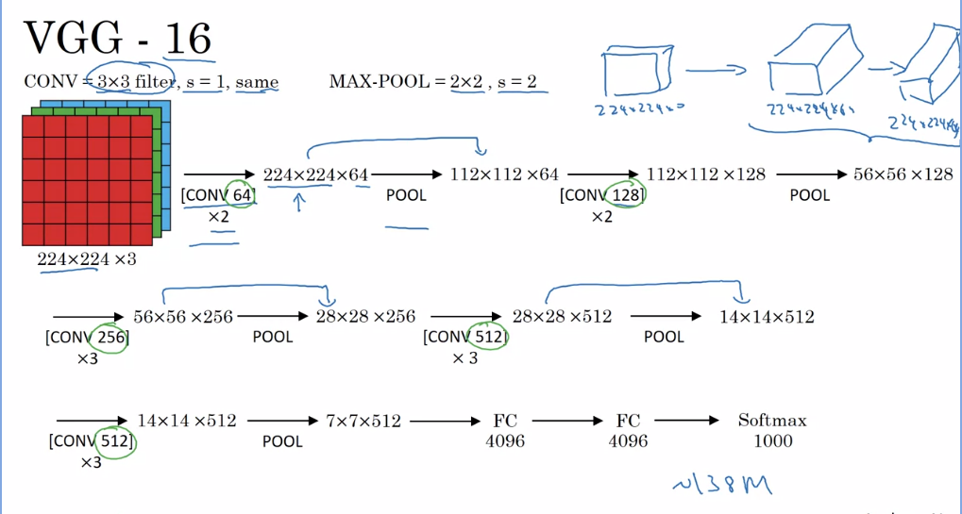

Residual networks:

**Residual block: $a^{\left[l+2\right]}=g\left(z^{\left[l+2\right]}+ a^{\left[l\right]}\right)$**

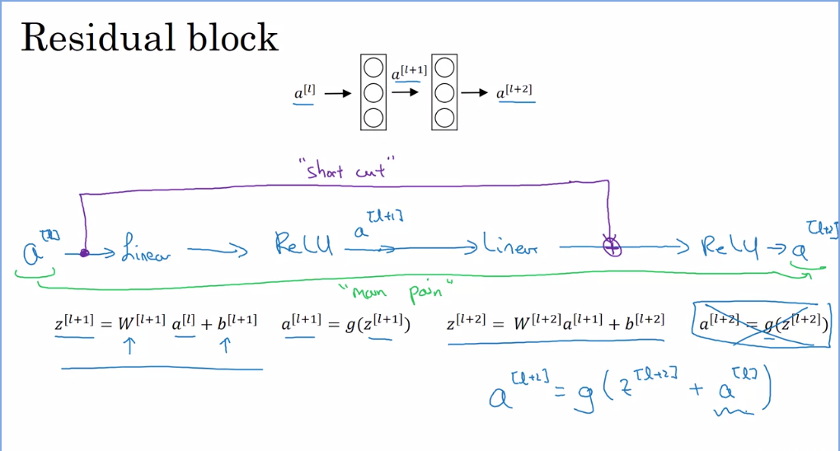

resBlocks learn the identity function:   
when $z^{\left[l+2\right]}$ is close to 0 then the activation (g = relu) of layer [l+2] will be very close to $a^{\left[l\right]}$, so in case of vanishing gradient there is no drop in preformence.

Identity block and conv block:

* The identity block can be used when $a^{\left[l\right]}$ and $z^{\left[l+2\right]}$ are of the same dimentions.
* When these matrixes differ in sizes, we apply a conv block, which applys a conv operation to $a^{\left[l\right]}$ to reshape it to same dims as $z^{\left[l+2\right]}$ (see diagrams in resNet assignment, course 4 week 2)

1x1 convolution & inception model:

**What is 1x1 conv doing:**  
a ($1*1*n_{c}$) filter can be thought as the weight matrix W of a single neuron in the output layer. The filter runs through all positions of the picture ($n_{h}*n_{w}$) across all channels – and for each position (of size ($1*1*n_{c}$)) it outputs a single value in the activation.

**Use of 1x1 conv**:  
1x1 conv can be used to shrink down inputs on the channel axis. For example, reduce a $28*28*192$ volume to $28*28*32$ using 32 filters of size 1x1. (this is used in resNets in the convBlock to help reshape $a^{\left[l\right]}$)

inception model: the combination of different filter sizes in a single layer of the network

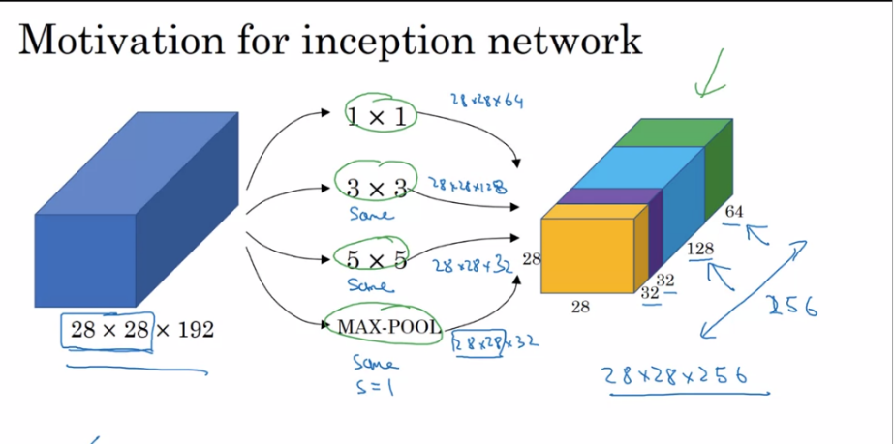

* computing an inception is computationally expensive. To reduce computation, we use 1x1 conv to the input to reduce num of channels before applying the actual filters.

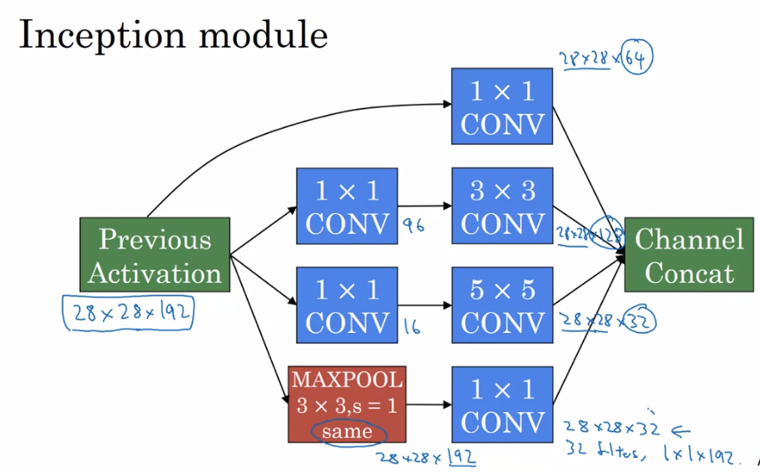

Practical advice for ConvNet

* Look for an appropriate open source implementation if you can
* **Transfer learning**
  + small training set:
    - Consider getting a pre-trained model and training the last layer yourself using your data set. (while training make to "freeze" the training on the pre-trained layers)
    - To speed up training: run forward prop on all examples using the pre trained layers and save the results -> use them directly to train the softmax layer.
  + Larger training set:
    - As your data set size increases you can train more layers of the pre trained layers by yourself. You can use the given weights as the init value or you can init them yourself
* **Data augmentation**:
  + Methods:
    - Mirroring the img, random cropping (of reasonable size), rotation
    - Color shifting (for more advanced algorithm search "PCA data augmentation)
  + For a big data set: can use a thread to load data & implement augmentation > pass it then forward to training.

Object localization:

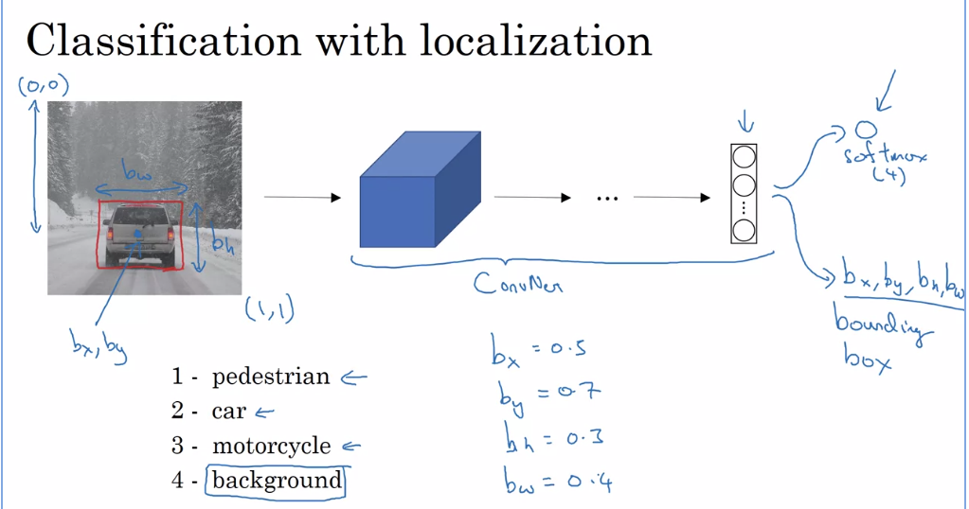

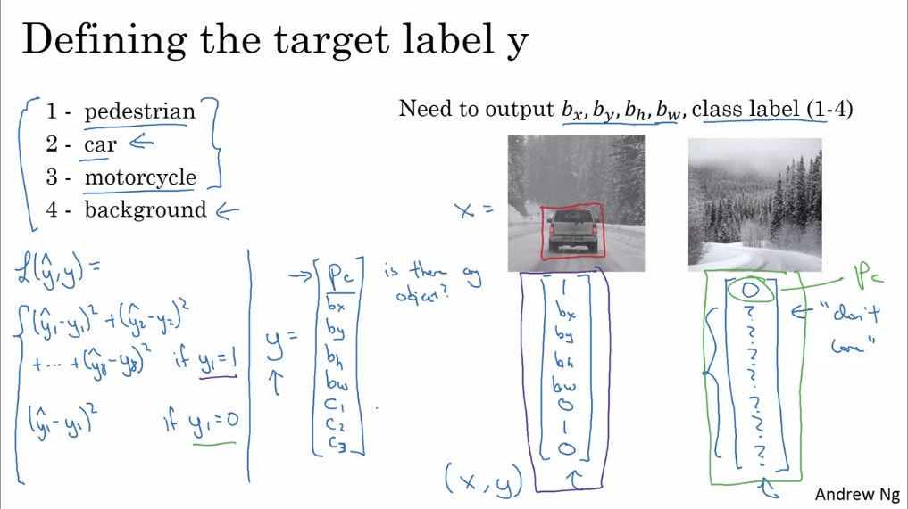

* land marks: instead of using only bx,by,bh,bw , you can add "landmarks" to your labeled data – specific points you want to track in your data. Ex: in face recognition track the eyes, nose and mouth.

Object detection:

**Sliding window detection**: using a sliding window over the input image, to crop one part of the image at a time and pass through a convNet. Main problem: very computationally expensive.

**Convolutional Sliding window**:

* Turing FC layers to conv layers (using 1x1 conv like seen before) 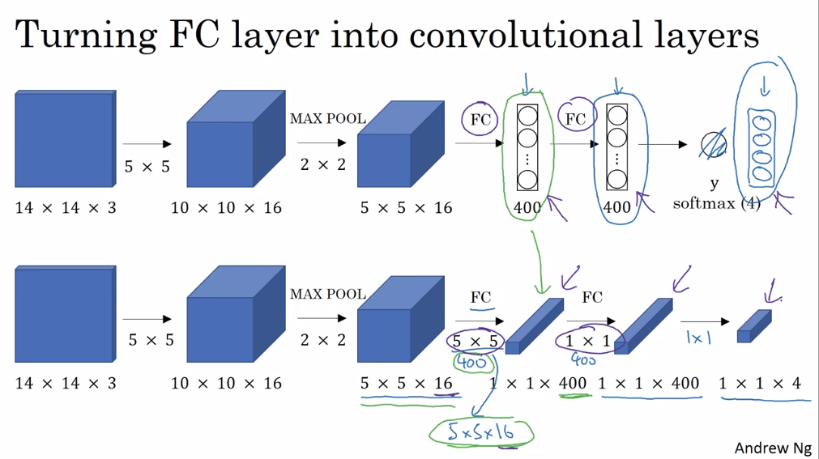
* Calculating all sliding windows at the same time: 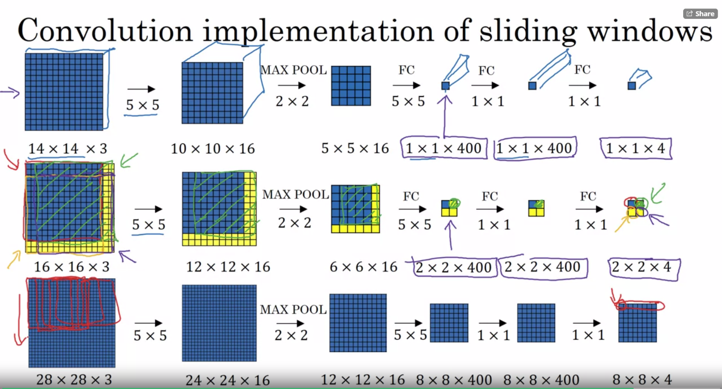

**Bounding box predictions**:

* YOLO algorithm: 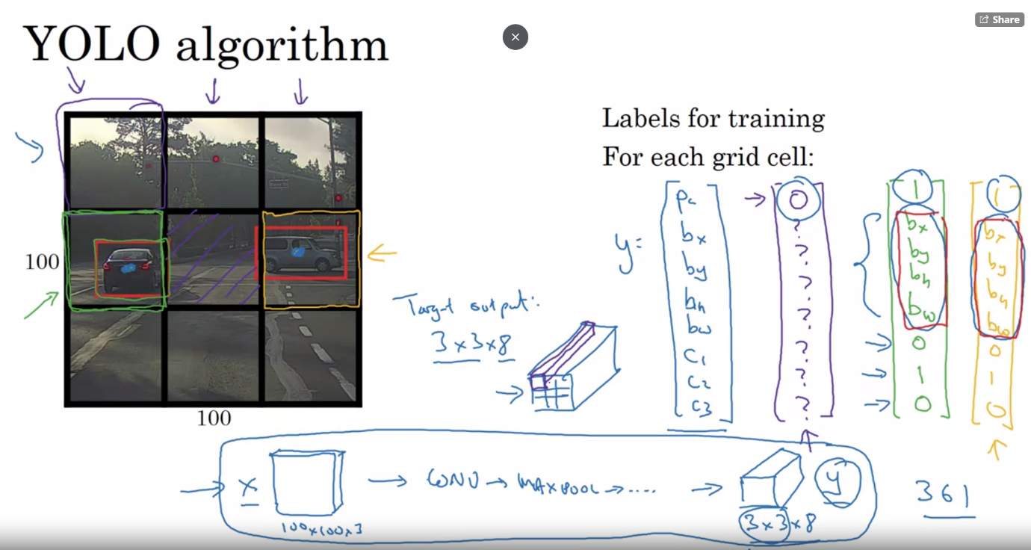
  + Divide input pic into a fixed grid (for ex: 3x3)
  + For each cell in the grid create a Y vector as seen in the picture. You end up with Y volume for each training pic (gridH x gridW x yVectorSize)
  + Train a Convolutional Sliding window like seen above
  + How to set the bounding box position:

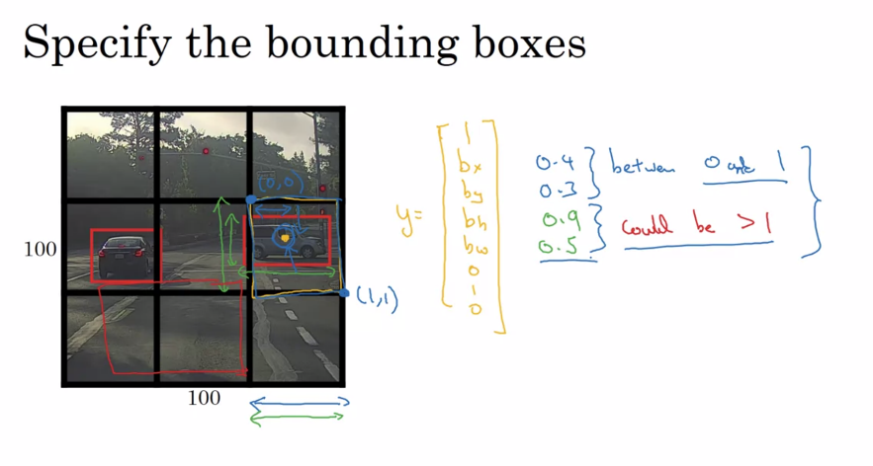:

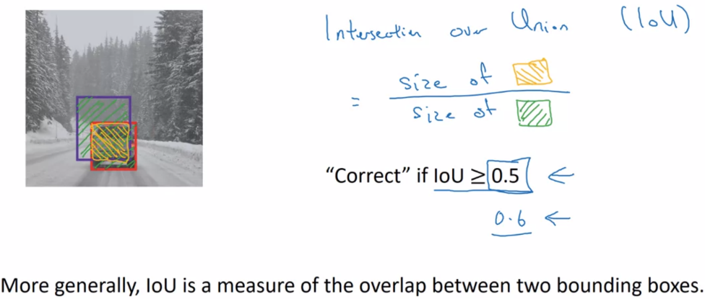 **Intersection over union:**

Non-max suppression:

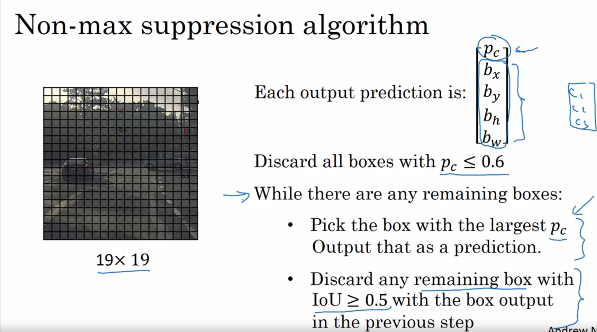

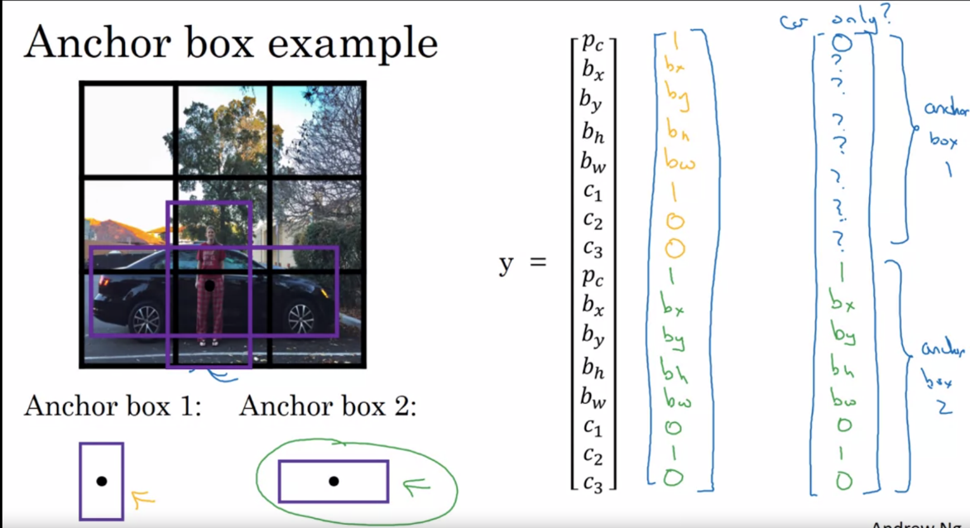 Anchor box algorithm:

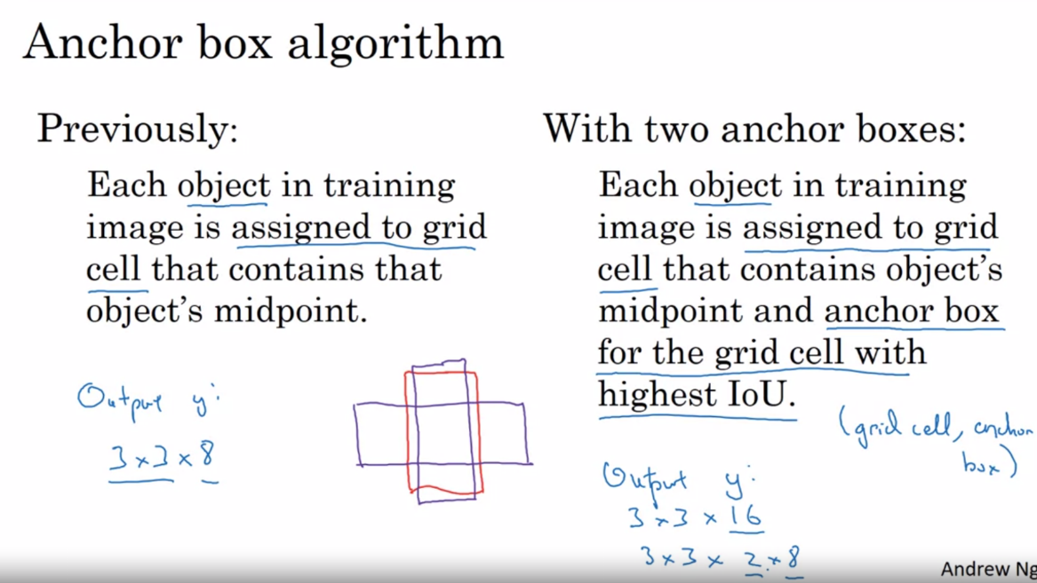

Face recognition:

**Face verification**: given input image & ID/name – verify if the face in the image belongs to the stated person. **Face recognition**: given input image – recognize if the person in the image is one of "K" amount of people stored in the database.

Face verification:

**One-shot problem**: in many cases you only have one picture of a person (rather than a full training set) -> impossible to train a CNN. **One shot learning:**   
Instead of a CNN we implement a function (d) that inputs 2 pictures and outputs the degree of difference between them: the larger the value -> the more the pictures differ.

To make a prediction we set a threshold value. Ex: thresh = 0.5 -> all predications >= 0.5 are a different person and predictions < 0.5 are the same person.

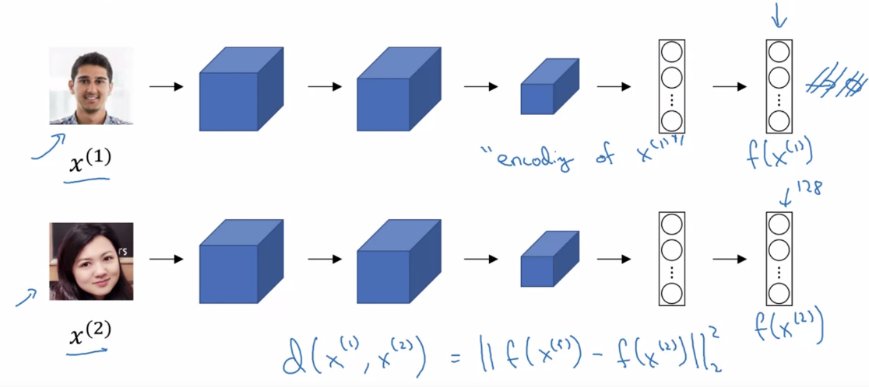**Siamese network**:

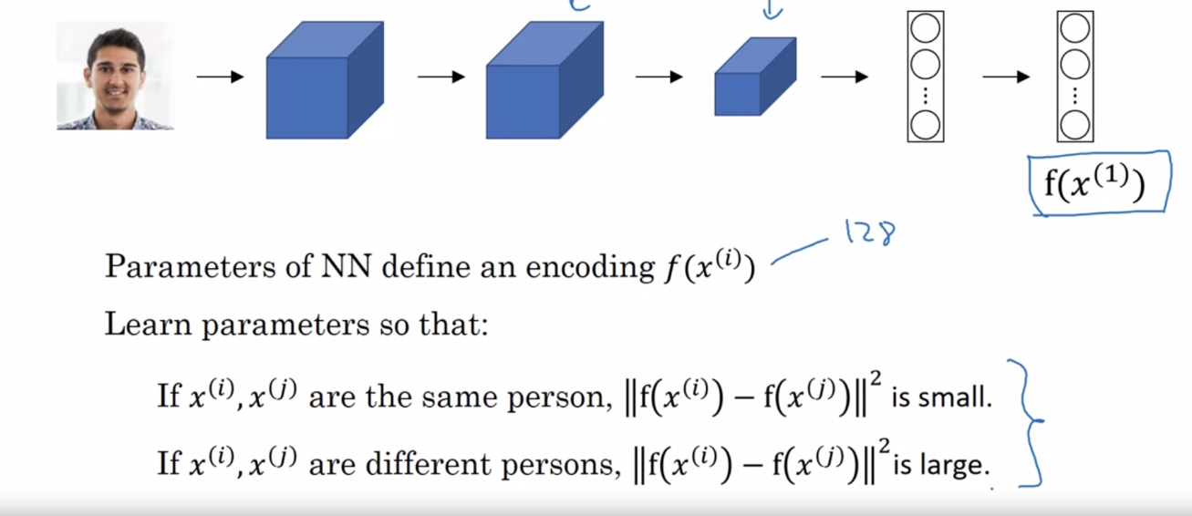**Triplet loss**:

Given 3 images: A, P, N (anchor, positive, negative) we compute:

$$l\left(A,P,N\right)=max⁡({\left|\left|f\left(A\right)-f\left(P\right)\right|\right|}^{2}- {\left|\left|f\left(A\right)-f\left(N\right)\right|\right|}^{2}+ α , 0)$$

$f\left(A\right)$– output of the convNet, the encoding of picture A.

${\left|\left|f\left(A\right)-f\left(P\right)\right|\right|}^{2}$– the squared norm of the encodings: the squared difference -> which means how they differ in value.

$α$– hyperparameter. Sets the value gap to the model to learn the difference between score of "same pictures" and "different pictures".   
Ex: $α=0.2$, ${\left|\left|f\left(A\right)-f\left(P\right)\right|\right|}^{2}=0.5$, ${\left|\left|f\left(A\right)-f\left(N\right)\right|\right|}^{2}=0.51$-> total value is bigger than 0. Model understands it need to enlarge ${\left|\left|f\left(A\right)-f\left(N\right)\right|\right|}^{2}$ or decrease ${\left|\left|f\left(A\right)-f\left(P\right)\right|\right|}^{2}$.

**Cost**:

$$J= \sum_{i=1}^{m}{l(A^{\left(i\right)},P^{\left(i\right)},N^{\left(i\right)})}$$

* To train a Siamese network need several different pictures of a person.
* Choose triples where d(A,P) is close d(A,N) -> triplets that are "hard" to train on, rather than initialize them randomly.

Face verification as binary classification:

1. Make a training set of pairs – one anchor image and one comparison picture.
2. Use your encoding function to evaluate both pictures.
3. Use the evaluations to train a logistic regression unit according to the relation of the pictures (same => predict 1, different => predict 0)
4. Use the training set to run gradient descent only on the logistic unit weights.
5. The activation can be the sigmoid of the element wise difference of the two encodings: $y= σ(\sum_{k=1}^{n}{(w_{k}*\left|{f\left(x^{\left(i\right)}\right)}_{k}-{f\left(x^{\left(j\right)}\right)}_{k}\right|+b))}$  
   *notation: n- number of encoding values, i,j – notation of a picture in the training set, w,b – parameters.